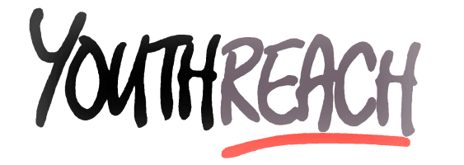
Further Education Centre, Cathedral Road, Ballina, Co. Mayo VEC

Tel: 096-71237 Fax: 096-71439 E-Mail:Paullarge@msletb.ie

Youthreach Ballina: Child Safeguarding Policy

Introduction
The Youthreach Ballina: Child Safe Guarding Policy (‘the policy )applies to all Trainees attending the centre. This edition was updated on September 2019. It has been drawn up in accordance with the Department of Education and Skills’ Child safe guarding procedures for Primary and Post Primary Schools.
Youthreach Ballina (‘the Centre’) is part of The Mayo, Sligo and Leitrim Education and Training Board. The MSLETB has final responsibility for the management of the Centre under the terms of the Vocational Education Act 1930 and all subsequent amending legislation.
Aims and Objectives
Ensuring the protection and welfare of children is the responsibility of all of us who interact with children and young people. Child safe guarding is therefore a priority for every school and must be at the core of all of its activities.
Policy Details
The Centre recognises that child safe guarding and welfare considerations permeate all aspects of school life and must be reflected in all of the schools’ policies, practices and activities. Accordingly, in accordance with the requirements of the Department of Education and Skills’ Child Protection Procedures for Primary and Post Primary Schools, the Ballina Centre has agreed the following child protection policy:
- The Centre has adopted and will implement fully and without modification the Department’s Child Safe Guarding Procedures for Primary and Post Primary Schools as part of this overall child protection policy.
- The Designated Liaison Person (DLP) is Paul Large
- The Deputy Designated Liaison Person (Deputy DLP) is Natasha Walshe
- In its policies, practices and activities, Youthreach Ballina will adhere to the following principles of best practice in child protection and welfare:
The Centre will
- Recognise that the protection and welfare of children is of paramount importance, regardless of all other considerations;
- fully co-operate with the relevant statutory authorities in relation to child protection and welfare matters
- adopt safe practices to minimise the possibility of harm or accidents happening to children and protect workers from the necessity to take unnecessary risks that may leave themselves open to accusations of abuse or neglect.
- develop a practice of openness with parents and encourage parental involvement in the education of their children; and
- fully respect confidentiality requirements in dealing with child protection matters.
The centre will also adhere to the above principles in relation to any adult pupil with a special vulnerability.
- This section of the child safe guarding policy should be used to list Centre policies, practices and activities that are particularly relevant to child protection (e.g. the Code of Behaviour/Anti-bullying Policy, Pupil Attendance Strategy , Supervision of pupils, Sporting Activities/Centre Outings/ Pupil Work Placements at post primary etc.)
The board has ensured that the necessary policies, protocols or practices as appropriate are in place in respect of each of the above listed items.
- This policy has been made available to Centre personnel and is readily accessible to parents on request. A copy of this policy will be made available to the Department and the patron if requested.
- This policy will be reviewed by the Centre Staff once in every academic Year.

This Child Safeguarding Statement was adopted by the Board of Management on __________________

Signed:__________________ Signed:_______________
Chairperson of Board of Management Principal/Secretary to the Board of Management

Date: ________________ Date:_______________

