Youthreach co-ordinator

P.F. Large

Further Education Centre

Cathedral Rd

Ballina

Tel: (096) 71237

Fax: (096) 71439

E-Mail: paullarge@msletb.ie

**Mayo, Sligo & Leitrim Education & Training Board**



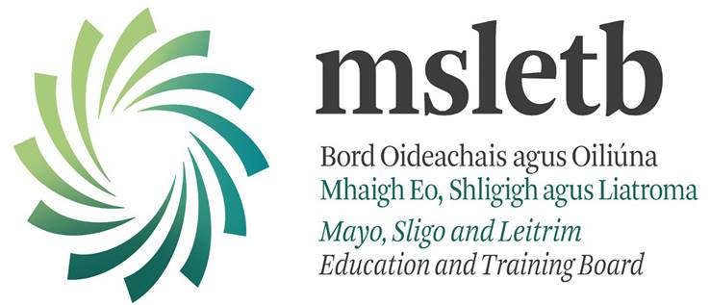

Internet

Usage

Policy

Ballina Youthreach will employ a number of strategies in order to maximise learning opportunities and reduce risks associated with the Internet. These strategies are as follows.

### General

* Internet sessions will always be supervised by a teacher
* Filtering software and/or equivalent systems will be used in order to minimise the risk of exposure to inappropriate material
* The Centre will regularly monitor students’ Internet usage
* Uploading and downloading of non-approved software will not be permitted
* Virus protection software will be used and updated on a regular basis
* The use of personal memory sticks will be permitted under supervision.
* Students will observe good “netiquette” (i.e. etiquette on the Internet) at all times and will not undertake any actions that may bring the Centre into disrepute

### World Wide Web

Students will not visit Internet sites that contain obscene, illegal, hateful or otherwise objectionable materials

* Students will use the Internet for educational purposes only
* Students will be familiar with copyright issues relating to online learning
* Students will never disclose or publicise personal information
* Students will be aware that any usage, including distributing or receiving information, Centre-related or personal, may be monitored for unusual activity, security and/or network management reasons
* While the Centre is aware that the Internet the Centre has access to through the NCTE Broadband for Centres Scheme is a subset of the World Wide Web, with unsuitable material filtered out, it will be vigilant in monitoring students’ surfing

### Email

* Students will not send or receive any material that is illegal, obscene, and defamatory or that is intended to annoy or intimidate another person
* Students will not reveal their own or other people’s personal details, such as addresses or telephone numbers or pictures
* Students will never arrange a face-to-face meeting with someone they only know through e-mails or the Internet
* Students will note that sending and receiving e-mail attachments is subject to permission from their teacher
* Students should respect each other’s privacy related to their student account.
* Approved student email accounts set up by MSLETB will be the preferred email account for student use (2015 – 2016 Centre year Microsoft Online accounts).

### Legislation

Teachers, students and parents should familiarise themselves with the relevant legislation, guidelines and support structures including:

* + Webwise.ie
  + Data Protection (Amendment) Act 2003
  + Child Trafficking and Pornography Act 1998
  + Interception Act 1993
  + Video Recordings Act 1989
  + The Data Protection Act 1988

Best practice as outlined by the Office of Internet Safety of the Department of Justice

This Policy should be read in conjunction with the Centre’s Anti-Bullying Policy (ref. Non-Fatal Offences Against the Person Act, 1997; Prohibition of Incitement to Hatred Act 1989, Defamation Act 2009).

### Sanctions

* Misuse of the Internet may result in disciplinary action, including written warnings, withdrawal of access privileges and, in extreme cases, suspension or expulsion.
* The Centre also reserves the right to report any illegal activities to the appropriate authorities.
* Action taken will be guided by the Centre’s Code of Behaviour and Anti-Bullying Policy.

### Internet Chat

* Students will only have access to chat rooms, discussion forums or other electronic communication forums that have been approved by the Centre
* Chat rooms, discussion forums or other electronic communication forums will only be used for educational purposes and will always be supervised
* Usernames will be used to avoid disclosure of identity
* Face-to-face meetings with someone organised via Internet chat will be forbidden.

 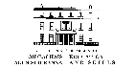 https://lh5.ggpht.com/Z0KiyWlcKNNjc2ffZZ3NHG7ubfjmjrOZECEUHl33IIeCDRyYsxaqW3sQNV7-sAZoep5uaA=s170 https://lh6.ggpht.com/0YiQoT67BTbn3vx6-Gz36Roj2MDtupeEOrgvxzPpiKEBMpczyHWB2e18cLLZN6ObdnkR=s170 C:\Users\CGormley\AppData\Local\Microsoft\Windows\Temporary Internet Files\Content.IE5\CB9NRKIS\solaslogo.png 







Youthreach is funded by the Department of Education and Science

With assistance from the European Union as part of the National Development Plan 2007 - 2013