Youthreach co-ordinator

P.F. Large

Further Education Centre

Cathedral Rd

Ballina

Tel: (096) 71237

Fax: (096) 71439

E-Mail: paullarge@msletb.ie

**Mayo, Sligo & Leitrim Education & Training Board**

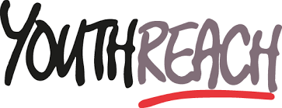

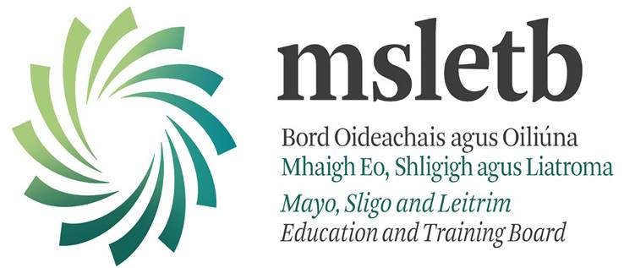

**SUBSTANCE USE POLICY**

**(Includes Drugs, Alcohol and Tobacco)**

***Definition of a drug***

A drug is defined as a chemical that causes changes in the way the human body functions mentally, physically and/or emotionally. These include legal drugs such as alcohol, solvents, tobacco, prescribed medication and illegal drugs of any description.

***Definition of drug misuse***

The Drug Treatment Centre Board defines drug misuse as drug taking which causes harm to the individual, their significant others or the wider community. Ballina Youthreach substance use policy was developed in conjunction with the ***Misuse of Drugs Act (1977, 1984 and 2006)*** which defines not only the use of illegal drugs in general but also the dangerous use of legal drugs such as alcohol, the use of tobacco, the harmful use of prescription medicines by exceeding the recommended dose or drinking and driving. Under the **Safety, Health and Welfare at Work Act (1989 and 2007)** all employers are required to provide a safe place of work, which includes a working environment free from tobacco and smoke.

***Objective***

Our aim, in conjunction with the ***Education Act (1998)*** is to provide the participants of Ballina Youthreach with the appropriate level of information and decision making skills to promote social and personal development and provide health education and general awareness of the dangers of both legal and illegal substances.

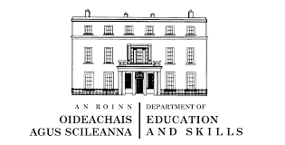

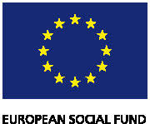

Youthreach is funded by the Department of Education and Science

With assistance from the European Union as part of the National Development Plan 2007 - 2013